**STT 810**

**ICA 6**

1. Define a probability density function as p(x) = cx on the interval 0 ≤ X ≤ 4.
   1. Determine what c is.

By normalizing

Integral is c*x2/2, Putting 0 and 4 as integral values, we get

**C = 1/8**

* 1. What is the probability that X < 2?

Putting value of x as 2 in cdf function F(x) = x2/16, we get 1/4.

**P(X<2) = 1/4**

1. Customers are entering a store at a rate of 1 every 4 minutes. Once a customer enters, find:
   1. The probability that another customer will arrive in the next 90 seconds.

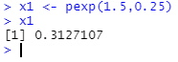

* 1. The probability that another customer will arrive in the next 90 seconds, given that a customer will arrive in the next 5 minutes.

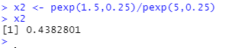

* 1. The probability that it will take more than 8 minutes for another customer to arrive?

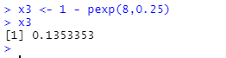

1. The silicon wafers produced at a semiconductor plant have a flatness deviation which fit a normal distribution with mean 10.0 μm with standard deviation 2.5 μm. If the wafer has a deviation greater than 16.7 μm, it is defective. The automated quality control system can detect if the deviation is greater than 17.0 μm.
   1. What is the probability that a wafer is defective?

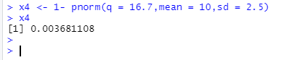

* 1. What is the probability that the quality control system will detect a defect in any wafer?

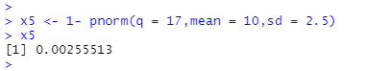

* 1. What is the probability that a wafer is defective *and* the quality control system does not detect the defect?

